**Data Preprocessing:**

1: Data in the excel was transposed to easily visualize it in Power BI.

2: Unwanted Missing Rows, Columns were removed.

3: Profiling is done in Power BI for any anomaly detection like missing value, duplicate value, Null Value.

**Patterns and Knowledge discovery from dashboard :**

* Lowest Inflation rate is -5.12% in 2009 and highest is 7.75% in 2003.
* Canada and Mexico were exporting almost all live animals product with very less contribution from rest of the world.
* Canada is the largest exporter of Grains contributing more than 50% of total value of grain import.
* Mexico is the largest exporter of fruits contributing more than 50% of total value of fruits import.
* USA is largely dependent upon Mexico for Vegetable which contribute more than 60% of total vegetables import.

**Data analytics Methods :**

* **Anomaly detection :**

**Animals:** For Sheep’s and Goats categories both Canada have 15 distinct and 10 unique values and World has 14 distinct and 11 unique value.

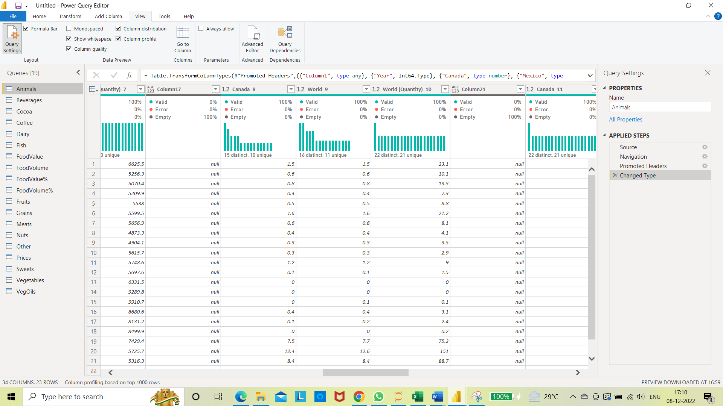

**Beverages:** For Malt beer Poland has 19 distinct and 16 unique values.

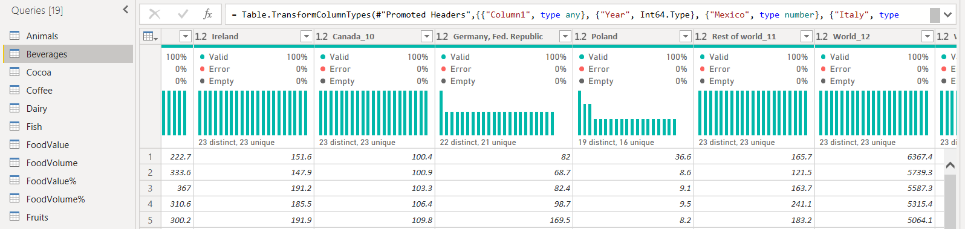

**Coffee-** There are multiple irregularities in coffee import dataset.

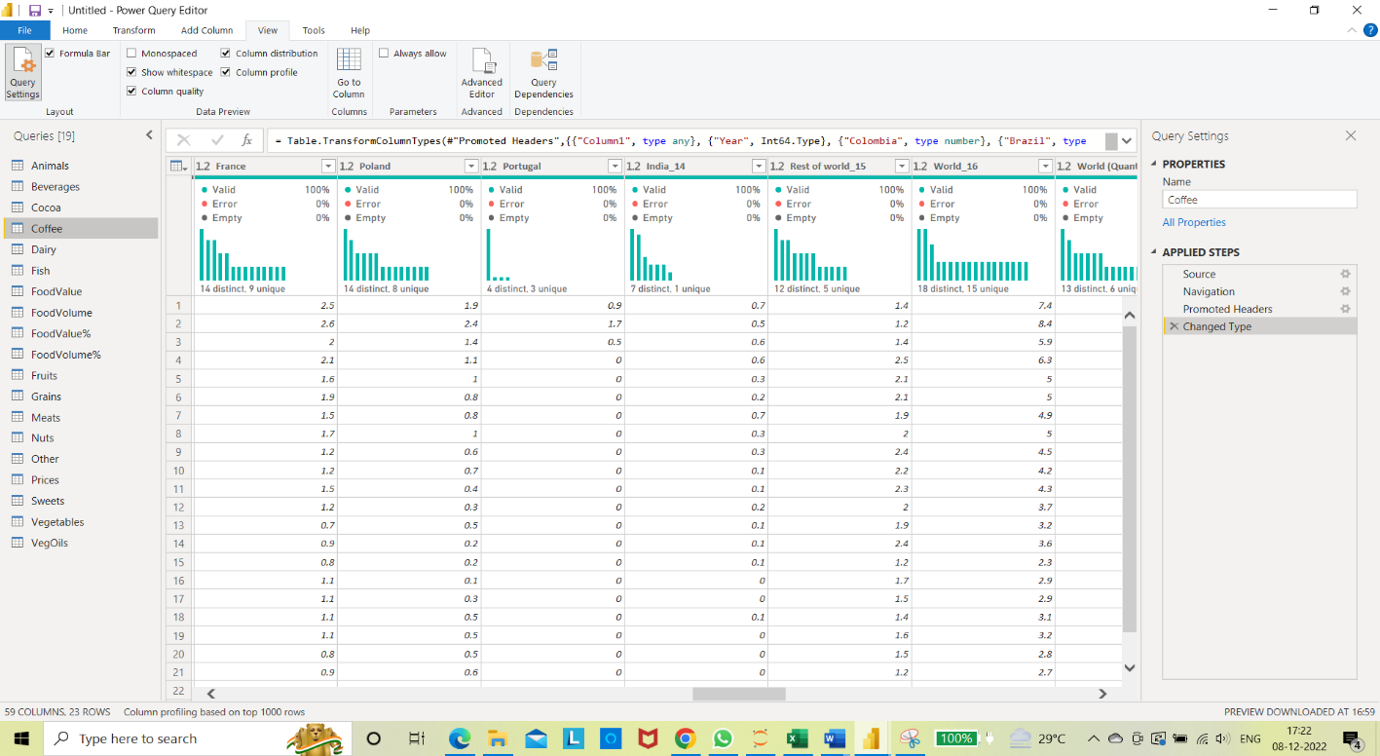

**Dairy:** There may be data irregularities or missing value for Denmark ,Germany , Mexico and Chile in Dairy dataset.

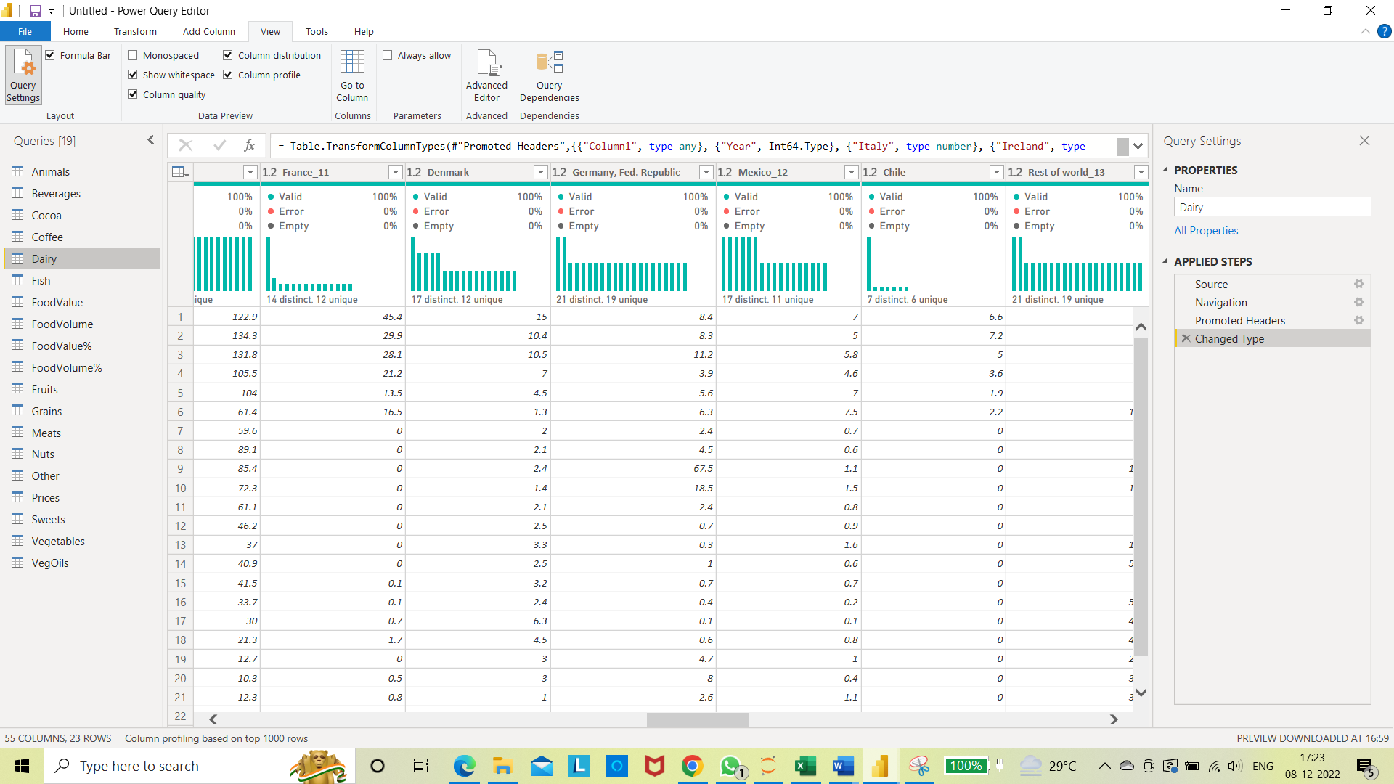

**Grains:** There are only 15 unique values of brazil in Grains dataset.

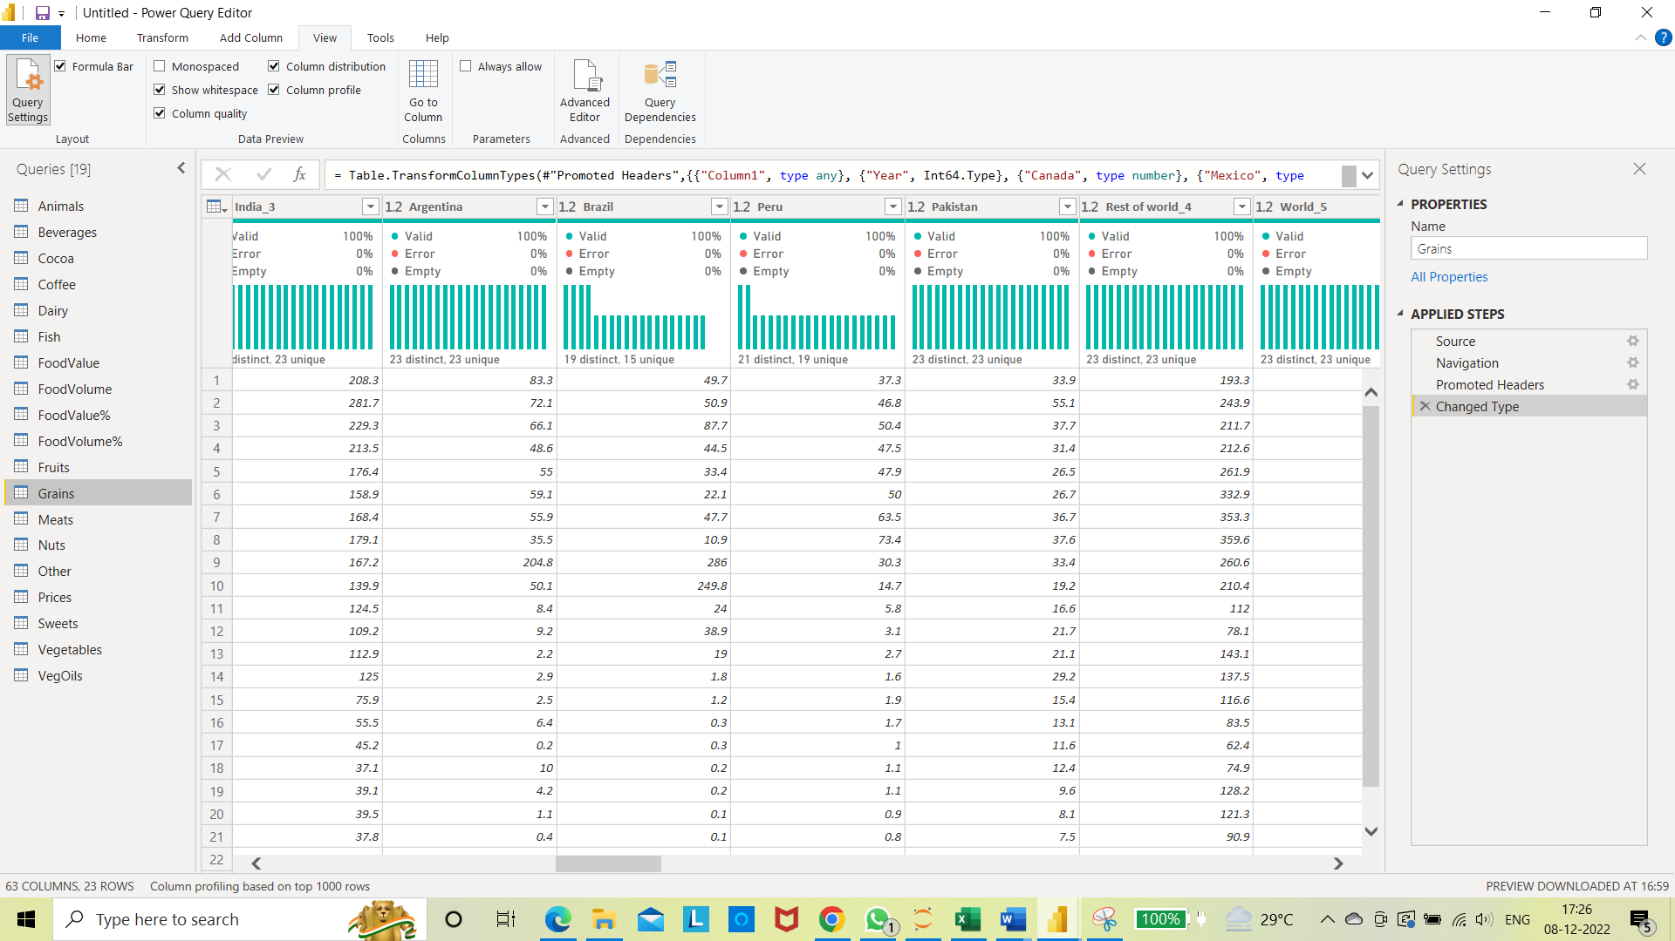

* **Demand forecasting for next five years :**

**Business Problem :**

**Accurately forecast demands for different categories of goods which will help to optimize :**

1. **the operations like in hiring appropriate amount of labour**
2. **to efficiently manage supply chain which will include carrying and shipping.**
3. **Port management, ware house management and inventory management.**

**Solution :**

Forecasting the demand will help improve the decision making process and we can plan accordingly in the future and it will help make good inter country relationship, indirectly it will also help to predict the estimated expenditure of USA for imports of next five years.

**Vegetables Demand in future :**

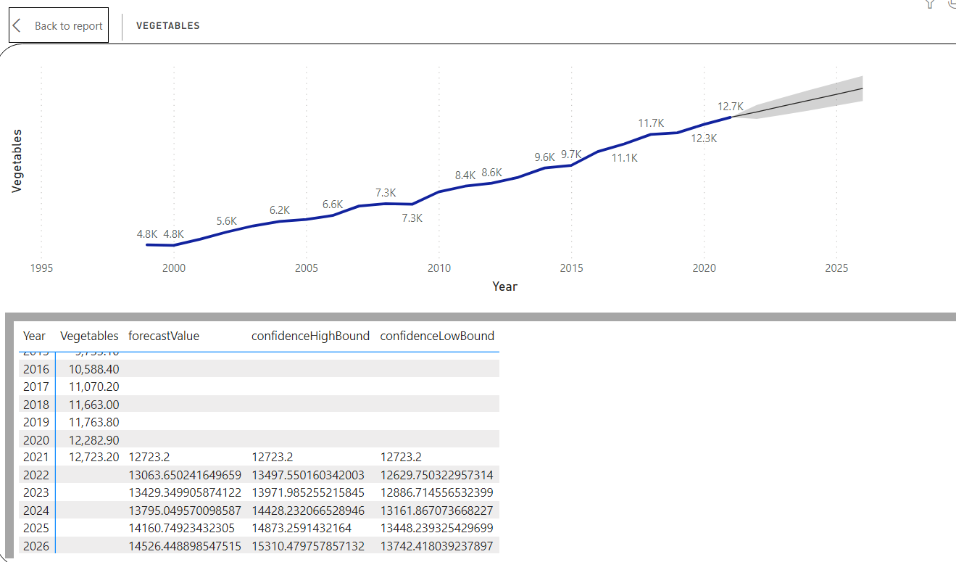

**Vegetable oils Demand in future :**

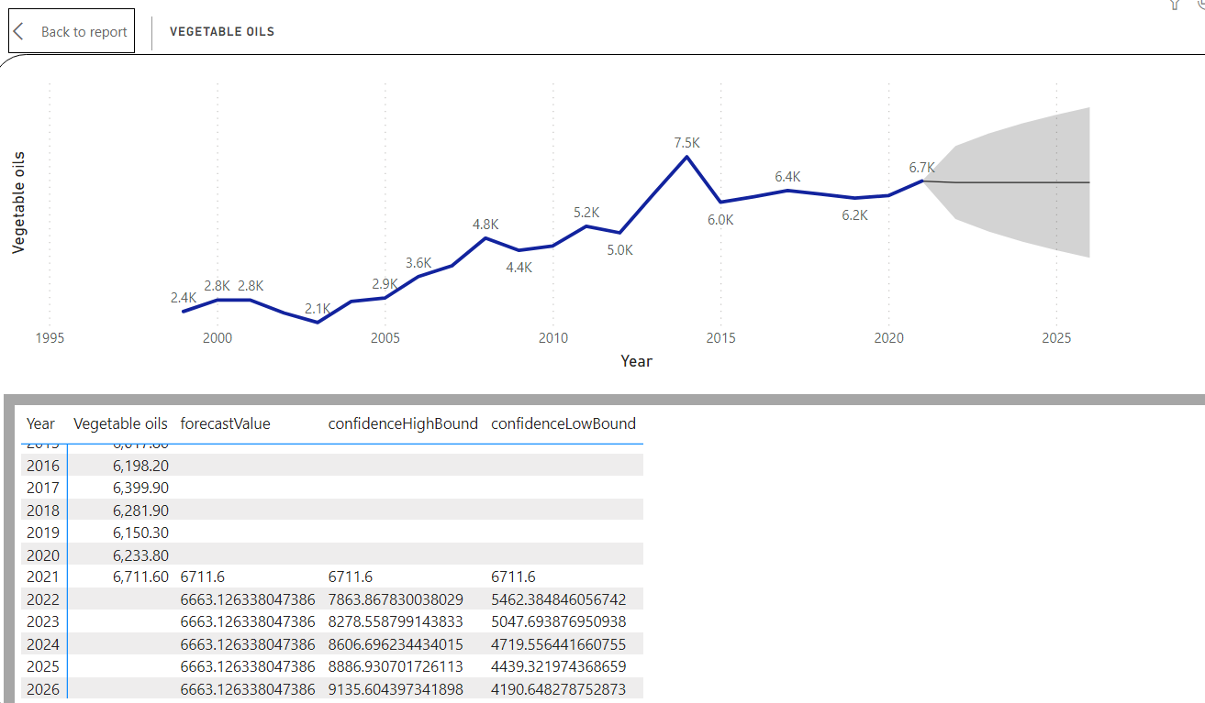

**Other edible products future demand:**

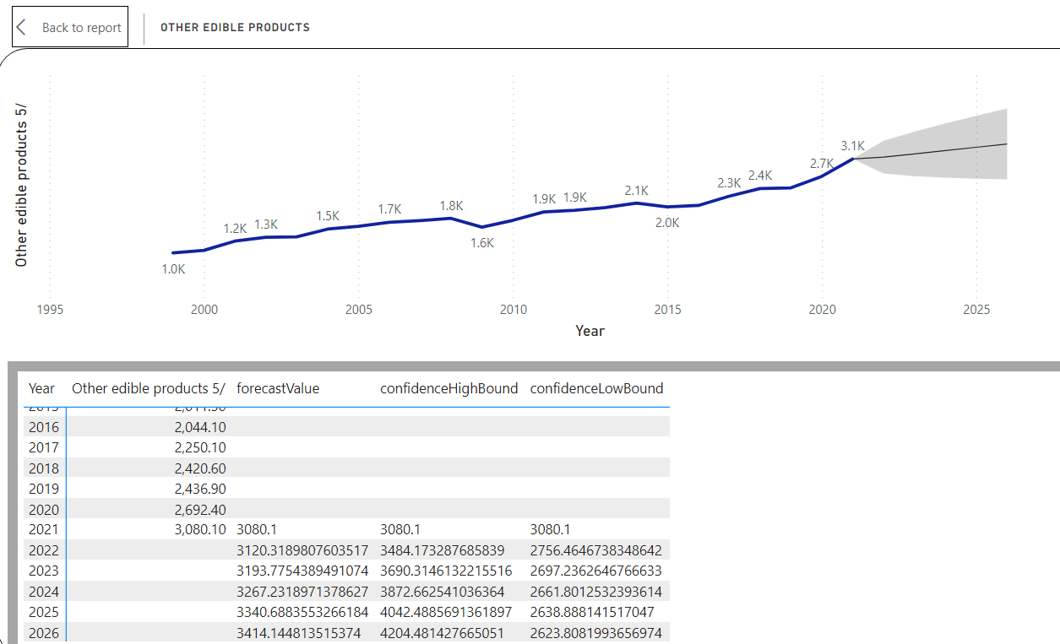

**Fish and Shellfish future demand:**

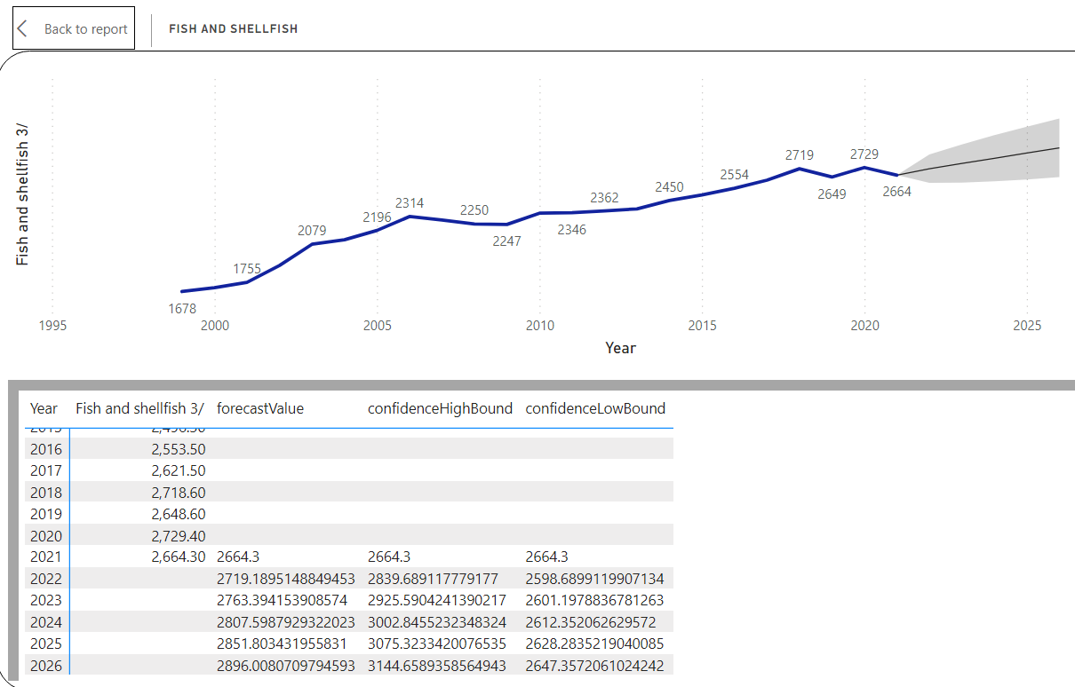

**Sugar and candy future demand:**

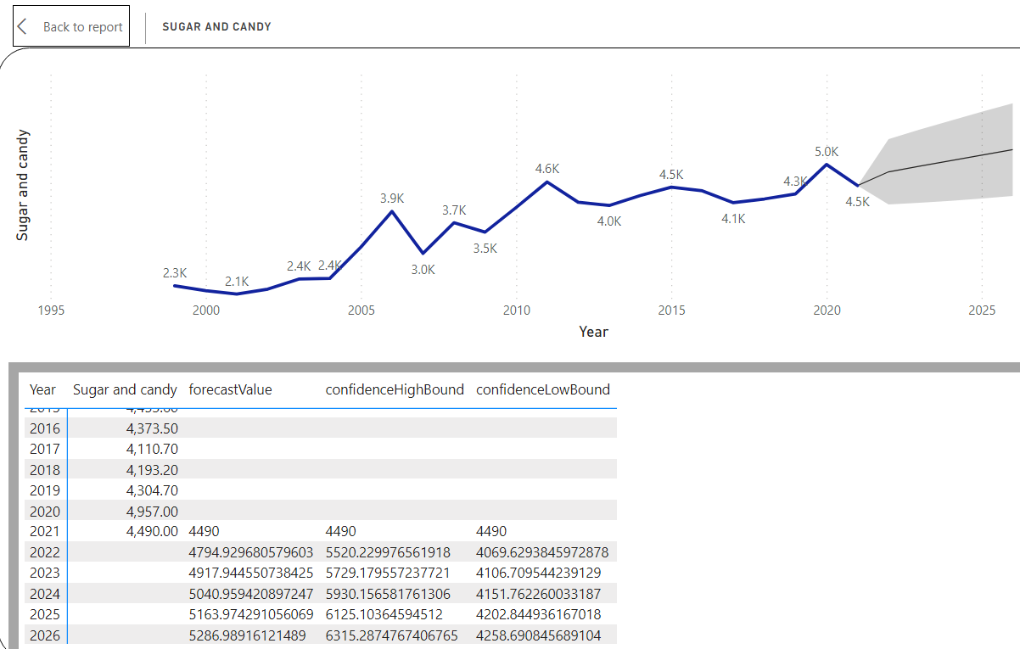

**Live meat animals future demand :**

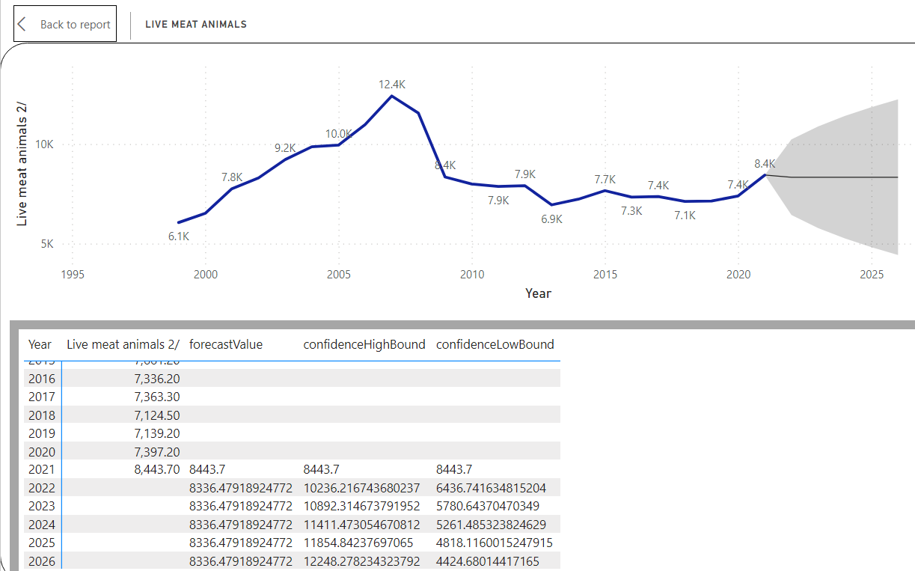

**Beverages future demand:**

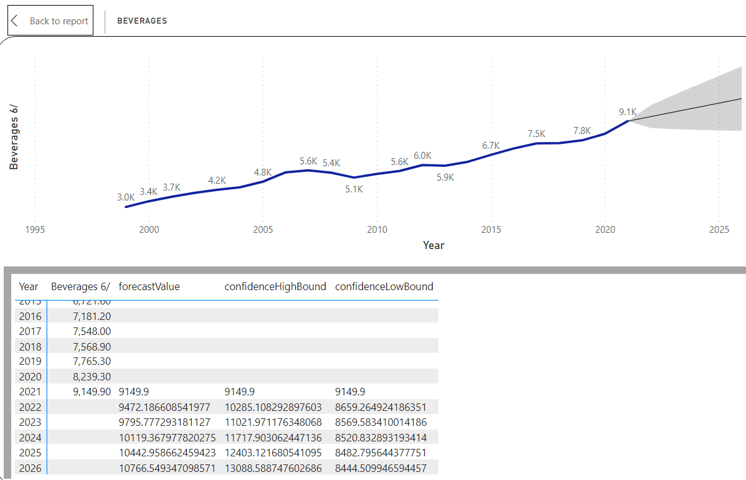

**Grains future demand :**

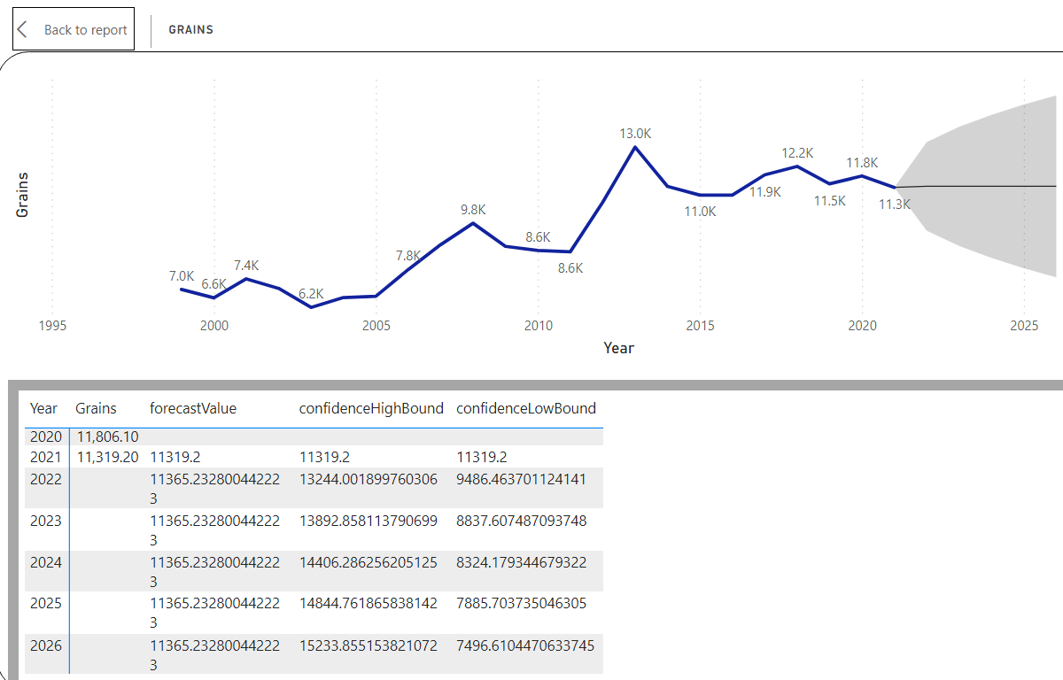

**Dairy future demand:**

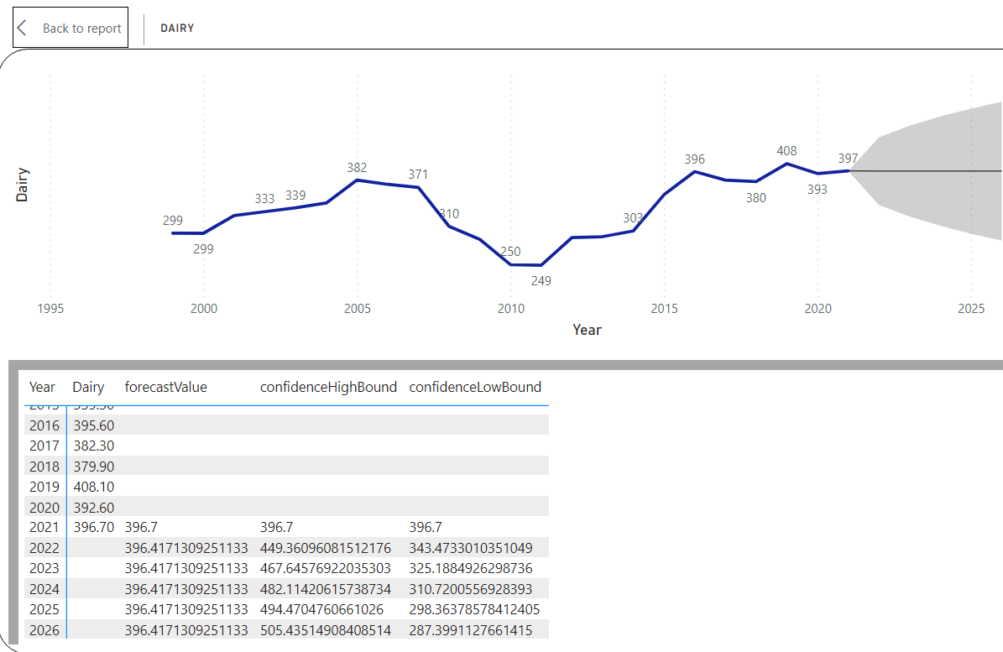

**Cocoa and chocolate:**

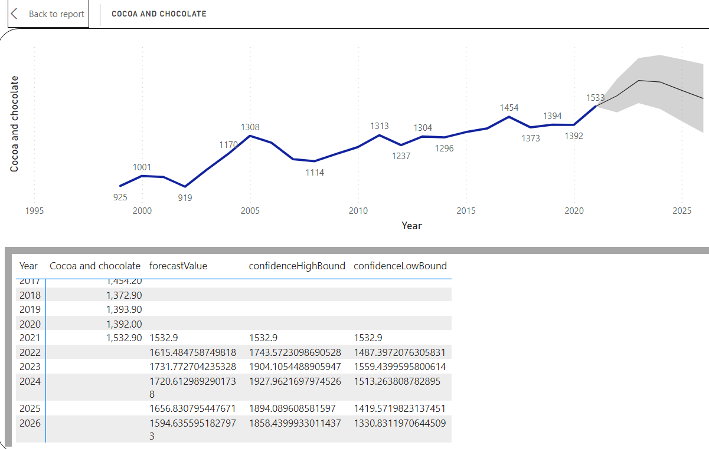

**Meats future demand:**

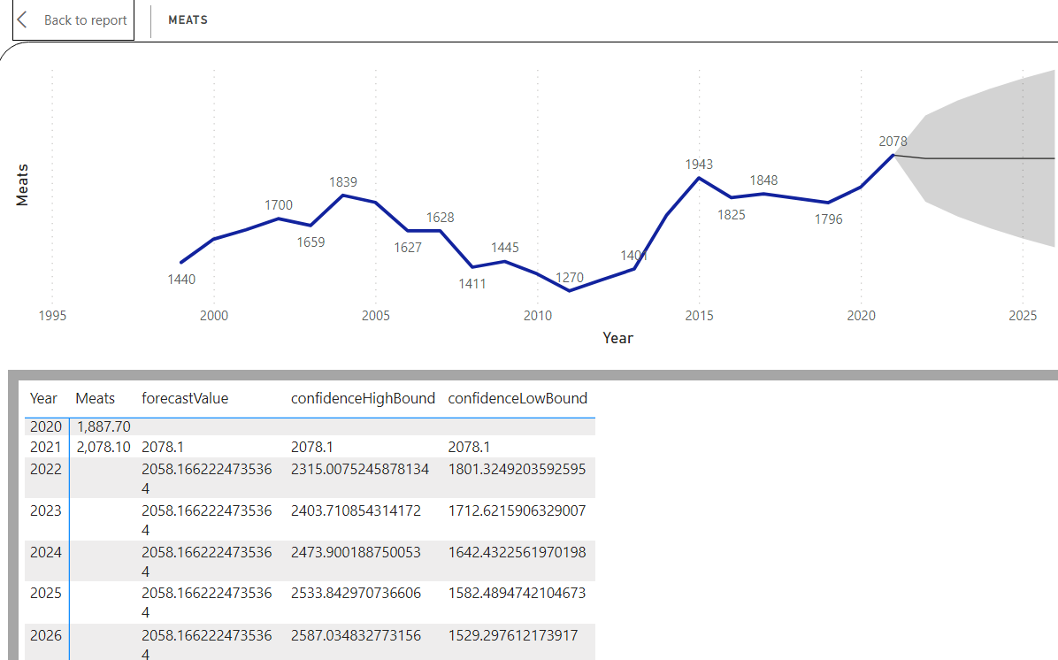

**Nuts future demand:**

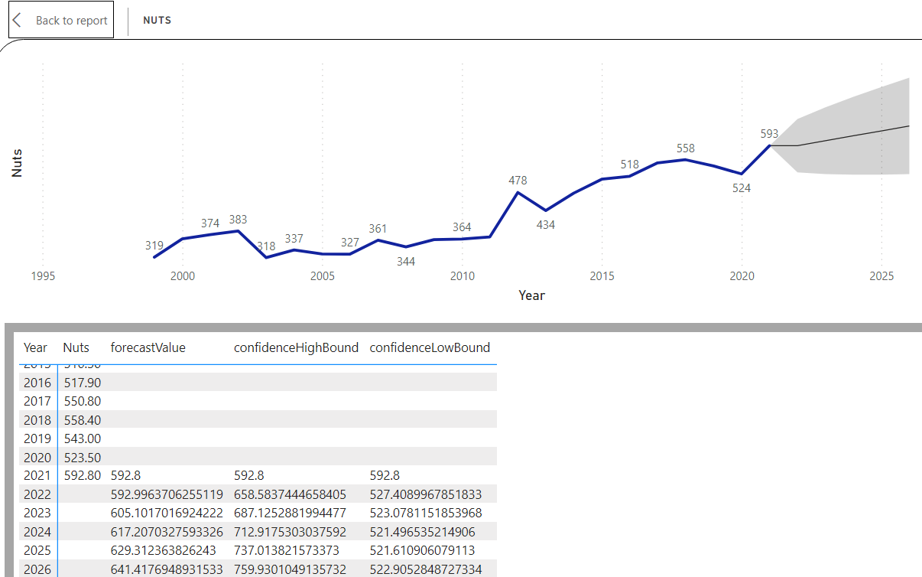

**Fruits future demand:**

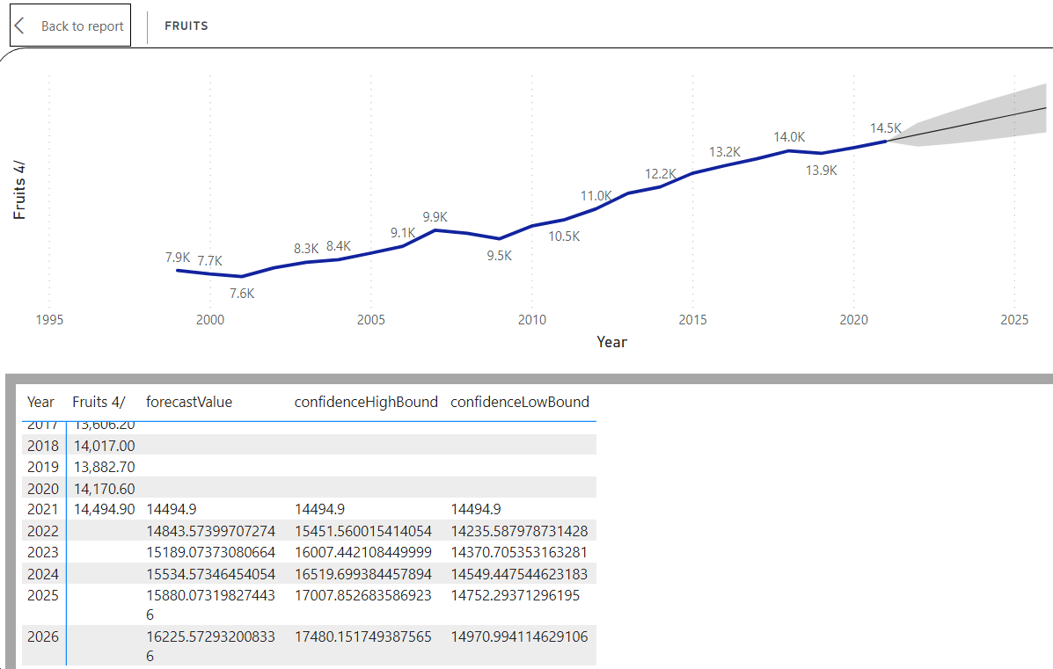

**Coffee, tea and spices future demand:**

